2025 PUBLIC HEARING MINUTES
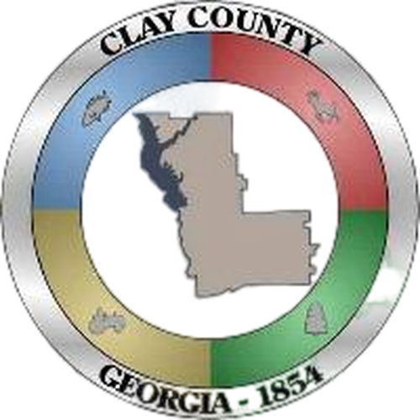

Public Hearing – FY 2026 Budget
July 1, 2025
4:30 p.m.

1) Call to Order and Opening Prayer
Chairman James Davenport called the public hearing to order at 4:30 p.m. Commissioner Samuel Johnson gave the opening prayer. Chairman James Davenport, Vice Chairman Lola Spann, Commissioners, Samuel Johnson, Gail Hubbard and Ronald Crozier were in attendance as well as Administrator/Clerk Ronald Dollar, Chamber Director Jacqueline Hunt and Deputy Clerk Temonica Ealey

2) Public Comments on Proposed Budget for Fiscal Year 2026
Chairman Davenport opened the floor for comments and/or questions on the fiscal year 2026 proposed
budget. Administrator Dollar recapped the proposed budget. Commissioner Crozier asked for an explanation on the 2024-2029 Splost that Clay County disburse to the City of Fort Gaines due to the City of Fort Gaines not paying the Law Enforcement agreement. Administrator Dollar discussed about increasing Refuse Tax from $18 to $20 and Tax Commissioner collecting annually. Administrator Dollar also recommended EMS Assessment fee be charged per E911 address not per parcel of land.

There were no public comments.

3) Adjourn
There being no further business the public hearing adjourned at 5:06 p.m.

______________________________ _______________________________
James Davenport, Chairman Date

I HEREBY AFFIRM THAT I AM THE DEPUTY COUNTY CLERK AND THAT THIS IS A TRUE AND CORRECT COPY OF THE July 1, 2025 PUBLIC HEARING OF THE CLAY COUNTY BOARD OF COMMISSIONERS.

______________________________ _______________________________
Temonica Ealey, Deputy County Clerk Date

